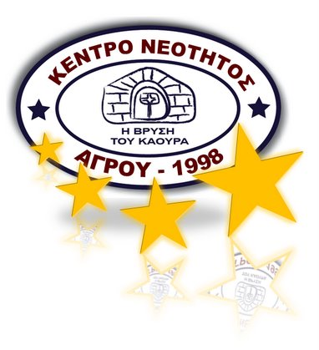

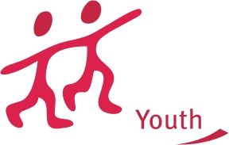

ACTION 4.3
INVITATION LETTER for A YOUTH EXCHANGE 3.1

Creative Entrepreneurship

Cyprus, for 1 April 2011

Agros Youth Group in Cyprus invites you to join their project.

We are looking forward to meeting you in Cyprus

ABOUT PROJECT

High levels of youth unemployment are always a source of concern because of the profound impact unemployment has on young people’s lives.
Studies of young people show that unemployment leads to a reduction in self-esteem, diminished levels of wellbeing and frequently isolation from peers.
The project Creative Entrepreneurship is developed with the motto that “a goal of every living creature is to break out of the box.”
Creative entrepreneurship is a path to stimulate young people's spirit of initiative, their ability to think imaginatively and originally, their readiness to take risk in order to achieve economic, political, social or environmental goals.
During the 8 days of the project we will implement activities and exercises that strengthen some of these basic creative entrepreneurship competences: team-building, facilitation, communication, intercultural competence and creative thinking skills. We will explore why creative thinking is considered a core entrepreneurship skill and enhance participants’ power as entrepreneurs by increasing their ability to think creatively.
Several methods will be combined to explore the topics: intercultural learning exercises, simulation exercises, discussions, creative thinking techniques, self-assessment inventories, reflection groups and presentations.

General aim of the project is to create an entrepreneurial and creative attitude and to help participants to develop initiative, pro-activity, independence and innovation in their personal and social life, as much as at work.
The training course will contribute not only to the personal development of the participants, but also promote exchange of best practices and establishment of new connections among all over the Europe.

OBJECTIVES and AIMS
- To lead an increase in self-esteem of the students and create a well being and effective atmosphere away from the isolation of peers.
- To provide the necessity atmosphere for the trainers that gives them the opportunity to break out of their boxes.
- To stimulate the spirit of young people and help them to think imaginatively and accordingly to increase their being initiative and achieve economic, political and social goals.
- With the help of the training course, to strengthen team-building, facilitation, communication, intercultural competence and creative thinking skills.
- To contribute not only to the personal development of the participants, but also promote exchange of best practices and establishment of new connections among all over the Europe
- With the methods applied in creative thinking, to enhance the level of entrepreneurs in terms of creative thinking.
- To create an entrepreneurial and creative attitude and to help participants to develop initiative, pro-activity, independence and innovation in their personal and social life, as much as at work.

WHAT LANGUAGE WE WILL USE: Language will be English.

WHO IS IT ADDRESSED TO?

The project is addressed to youth people and youth workers aged 18-30 interested in global issues and youth projects.
We are interested in partners from EU member countries, from neigbour partner countries and NGOs who had experiences In Youth Participation and Youth Projects.

HOW CAN YOU PARTICIPATE?

DEADLINE: 20th March 2011

- Please inform us by sending an e-mail regarding your participation and send your scanned Part III to vasilis@cing.ac.cy and also via fax 00357-25521007

- Send the Part III of your organization by post to this address:

Address:
Mr. Vasilis Christofi
A. Anastasopoulou 24, Flat 3. Engomi 2402, Nicosia, Cyprus
Tel: 00357-99473782
Fax: 00357-25521007

ATTENTION: Pls send Part III’s WORD VERSION…..

• We should get the original part III by fax 25 March 2011. And post date will be longer from that time.

Contact:
Mr. Vasilis Christofi
Tel: 00357-99473782 (Organiser & Project Manager)

Mr. Francesco Leone (from Italy) ( Project Trainer)
Tel: (+39) 320 903 92 55

vasilis@cing.ac.cy

Fraleone@hotmail.com

COSTS 100% of the accommodation and visa cost will be covered, according to youth program regulations.

TRAVEL EXPENSES: There will be a refund of 70% of the travel expenses.

DATES AND VENUE OF THE MEETING: September 2011,
8 days (excluding travel dates)

Part III. Partner promoter(s)
A. Details of the partner
Name
Street address
Postcode |  |  |  |  |  | City
Region |  |  |  |  |  | Country
Email |  |  |  |  |  | Website
Telephone |  |  |  |  |  | Telefax
Person in charge of the project (contact person)
Family name (Ms/Mr) |  |  |  |  |  | First name
Position/function
Email
Telephone |  |  |  |  |  | Telefax
B. Profile of the partner
Type and status | Non profit/non governmental organisation |  |  | Public body Informal group of young people
 | Body active at European level in the field of youth (ENGO) |  |  | Other – please specify:
Activity level | Local |  | Regional |  | National |  |  | European/International
 | Member organisation of the applicant
Please give a short description of your organisation/group (regular activities, member of, etc.) :

C. Preliminary agreement of the partner
I, the undersigned, on behalf of (repeat the name of the partner)
confirm our participation in each stage of the project (repeat the title of the project as stated in Part I):
Creative Entrepreneurship
I declare having reached an agreement with all the promoters involved in the project with regard to the share of EU grant my organisation/group is entitled to receive in order to implement the project.
Furthermore, I confirm my undertaking to ensure visibility of the European Union support for the project and to ensure dissemination and exploitation of its results.
Name in capital letters:
Place: |  | Signature:
Date: |  | Signature:

